1. Create table employee(

Empid int,

Emp_salary int,

Emp_lastname varchar,

Emp_firstname text,

Emp_dob date,

Emp_deptno int,

Emp_comm float,

Primary key((Empid,Emp_salary),Emp_firstname,emp_dob)

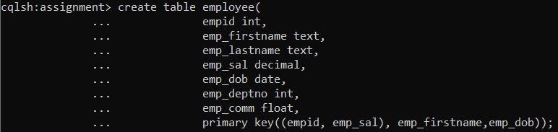

1Select * from employee Where empid in (1001,1002)

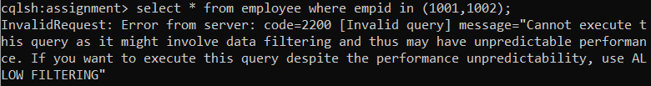

2 Select * from employee

Where empid=1001 and emp_dob=’1999-11-11’ and emp_salary=5000 and

emp_firstname=’Rajan’

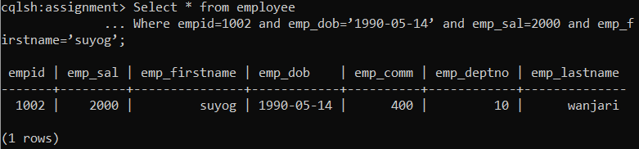

3 Select * from employee

Where empid=1001 and emp_dob=’1999-11-11’ and emp_salary>2000 and emp_firstname=’Rajan’

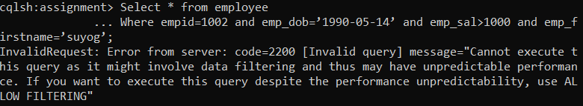

4 Select * from employee

Where empid=1001 and emp_dob=’1999-11-11’ and emp_salary>5000 and emp_salary<15000

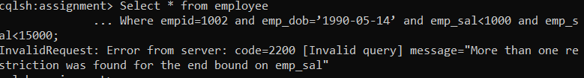

5 Select * from employee

Where empid=1001 and emp_dob=’1999-11-11’ and emp_salary>5000 and emp_dept>10

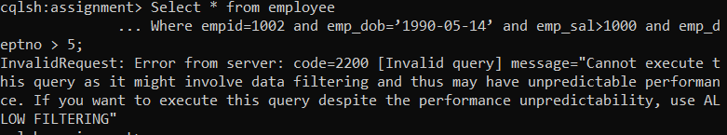

6 Select * from employee

Where empid=1001 and emp_dob=’1999-11-11’ and emp_salary>5000 and emp_dept>10

ALLOW FILTERING;

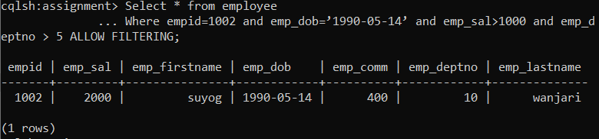

Q2 Create table to store information about singer, use appropriate collections to store data

Sid and name will be primary key

Sid integer, name string, store list of songs he/she sung, store list of music directors names and how

many songs he sung with the director, store names of studios where recordings have been done and

how many times recording has been done in the studio, also store movie, director name and song in

the movie he/she sung.

A. Write query to add new director name and count 1 in the table

B. List all records of ‘sonu nigam’

C. Add new studio in ‘shan’ and ‘shreya’s list

D. Perform batch operation to insert 2 records and delete 1 record from above table

E. Delete list of studios and movies from above table from ‘shan’ and ‘sonu nigam’s record.

